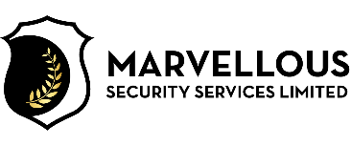
HEALTH AND SAFETY POLICY STATEMENT
Marvellous Security Services Limited Provide security guarding and key holding and intruder alarm response services to residential and business premises while. At Marvellous Security Services Limited the top management is committed to provide adequate control of the health and safety risks arising from our work activities under the Health and Safety at Work etc. Act 1974; by consulting with its employees on matters affecting their health and safety at workplace. Marvellous Security Services Limited ensures safe handling and use of substances and provides adequate information instruction and supervision for employees.
Marvellous Security Services Limited is committed to ensure that all employees are competent to do their tasks, and to give them adequate training. Marvellous Security Services Limited as employer understand his responsibility to report certain serious workplace accidents, occupational diseases and specified dangerous occurrences (near misses) under RIDDOR - Reporting of Injuries, Diseases and Dangerous Occurrences Regulations 2013. Marvellous Security Services Limited is committed to prevent accidents and cases of work-related ill health to maintain safe and healthy working conditions;
Therefore, we provide, so far is reasonably practicable.
- A safe system of work.
- Safe plant and equipment.
- Safe means of handling and transporting articles, substances and people
- Adequate training, instruction, information and supervision
- A safe place of work with safe access and egress.
- A safe and healthy environment.
- Adequate welfare facilities.
Management at Marvellous Security Services Limited is committed to ensure, so far as is reasonably practicable, that the way we carry out our security operations does not affect the Health and Safety of persons who are not our employees, for example visitor and contractors.
It is also recognized that where we produce articles and substances for use at work or we erect or install any plant or equipment, we have a duty to ensure the Health and Safety or those who use them and make available all the required information for their Health and Safety.
The Managing Director shall review this policy annually or following significant changes.
Mr Abdul Wahaab
Marvellous Security Services Limited
This policy is reviewed on 15-05-2023

